**BANK DATABASE**

CREATING TABLES SQL QUERIES :

create table pruthvi_bank.branch(

Branch_name varchar(30),

Branch_city varchar(25),

assets int,

PRIMARY KEY (Branch_name)

);

desc branch ;

create table pruthvi_bank.BankAccount(

Accno int,

Branch_name varchar(30),

Balance int,

PRIMARY KEY(Accno),

foreign key (Branch_name) references branch(Branch_name)

);

desc BankAccount ;

create table pruthvi_bank.BankCustomer(

Customername varchar(20),

Customer_street varchar(30),

CustomerCity varchar (35),

PRIMARY KEY(Customername)

);

create table pruthvi_bank.Depositer(

Customername varchar(20),

Accno int,

PRIMARY KEY(Customername,Accno),

foreign key (Accno) references BankAccount(Accno),

foreign key (Customername) references BankCustomer(Customername)

);

create table pruthvi_bank.Loan(

Loan_number int,

Branch_name varchar(30),

Amount int,

PRIMARY KEY(Loan_number),

foreign key (Branch_name) references branch(Branch_name)

);

INSERTING VALUES SQL QUERIES :

insert into branch values("SBI_Chamrajpet","Bangalore",50000);

insert into branch values("SBI_ResidencyRoad","Bangalore",10000);

insert into branch values("SBI_ShivajiRoad","Bombay",20000);

insert into branch values("SBI_ParlimentRoad","Delhi",10000);

insert into branch values("SBI_Varthur","Delhi",20000);

insert into BankAccount values(1,"SBI_Chamrajpet",2000);

insert into BankAccount values(2,"SBI_ResidencyRoad",5000);

insert into BankAccount values(3,"SBI_ShivajiRoad",6000);

insert into BankAccount values(4,"SBI_ParlimentRoad",9000);

insert into BankAccount values(5,"SBI_Varthur",8000);

insert into BankAccount values(6,"SBI_ShivajiRoad",4000);

insert into BankAccount values(8,"SBI_ResidencyRoad",4000);

insert into BankAccount values(9,"SBI_ParlimentRoad",3000);

insert into BankAccount values(10,"SBI_ResidencyRoad",5000);

insert into BankAccount values(11,"SBI_Varthur",2000);

insert into BankCustomer values("Hethish","Bull_Temple_Road","Bangalore");

insert into BankCustomer values("Hrithik","Bannergatta_Road","Bangalore");

insert into BankCustomer values("Prakash","NationalCollege_Road","Bangalore");

insert into BankCustomer values("Puneet","Akbar_Road","Delhi");

insert into BankCustomer values("Ravi","Prithviraj_Road","Delhi");

insert into Depositer values("Hethish",1);

insert into Depositer values("Hrithik",2);

insert into Depositer values("Puneet",4);

insert into Depositer values("Ravi",5);

insert into Depositer values("Hethish",8);

insert into Depositer values("Prakash",9);

insert into Depositer values("Hrithik",10);

insert into Depositer values("Puneet",11);

insert into Loan values(1,"SBI_Chamrajpet",1000);

insert into Loan values(2,"SBI_ResidencyRoad",2000);

insert into Loan values(3,"SBI_ShivajiRoad",3000);

insert into Loan values(4,"SBI_ParlimentRoad",4000);

insert into Loan values(5,"SBI_Varthur",5000);

OUTPUT QUEIRES AND SCREENSHOTS :

select * from branch;

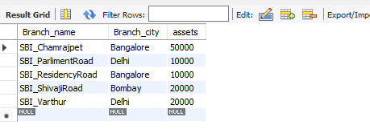

select * from BankAccount;

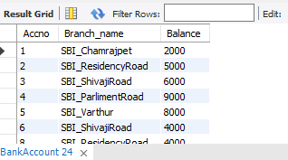

select * from BankCustomer;

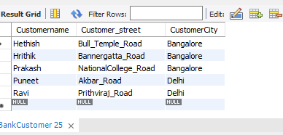

select * from Depositer;

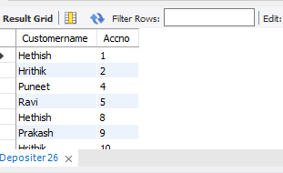

select * from loan;

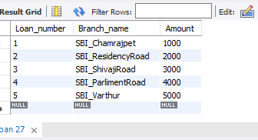

select Branch_name, CONCAT(assets/100000,' lakhs')assets_in_lakhs from branch;

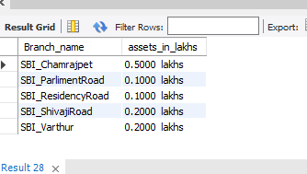

select d.Customername from Depositer d, BankAccount b where b.Branch_name='SBI_ResidencyRoad' and d.Accno=b.Accno group by d.Customername having count(d.Accno)>=2;

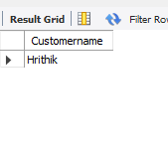

create view sum_of_loan

as select Branch_name, SUM(Balance)

from BankAccount

group by Branch_name;

select * from sum_of_loan;

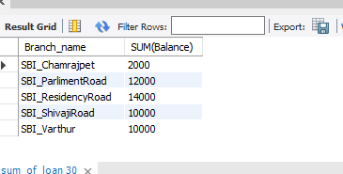

select bc.Customername, CONCAT(Balance+1000,' rupees') UPDATED_BALANCE from BankAccount b, BankCustomer bc, Depositer d where bc.Customername=d.Customername and b.Accno=d.Accno and bc.Customercity='Bangalore';

